

Reach Trivia User Manual

Janujan, Kevin, Lily, Pavneet



January 24, 2017

Reach Trivia

About Program:

This application is a one-player trivia game that is targeted towards Reach for the Top members and anyone else who is interested in playing trivia games. Each player has to create an account to keep track of their scores and statistics. The player can choose which category he or she would like to play. Each quiz is focused on a certain subject (e.g. physics, history, mathematics, etc.). The player can also create their own quiz for a category or contribute questions to existing quizzes and categories. Statistics are compiled for each player and a history of their most recent games is stored. This data will help players identify their strengths and weaknesses to improve their performance.

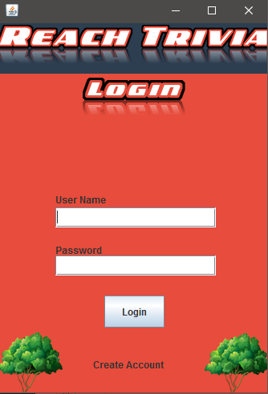

Account Login:

Logging In

It will either give you access or deny your access to the Trivia Home Screen. You must enter your user name and password. If there is a problem (Ex. Invalid username or password does not with inputted username), it will deny your access to the Home Menu. Otherwise, it will open the Home Menu with your information.

Creating an Account

If you do not have an account, you can click on the “Create an Account” label at the bottom (On Login Screen). Once done, you can input your information and click on Create Account. This will store your information into a text file. You will then be a member of the Reach Trivia Community.

Home Menu:

Creating a Quiz

There is a label on the left side called “Create”. Once this label is clicked, you can create your own quiz.

Viewing Statistics

There is a label on the left side called “Statistics”. Once this label is clicked, you can view your statistics for Reach Trivia. The statistics include Number of Quizzes attempted, Total Questions Attempted, Number of Correct Answers you have got, Overall Percentage, and you Average Time.

Entering Settings

There is a label on the left side called “Settings. Once this label is clicked, you must verify your login in order to make any changes to your information.

Logging Out

There is a label on the left side called “Logout”. Once this label is clicked, it will log you out of your account and it will return to the login screen.

Create a Quiz:

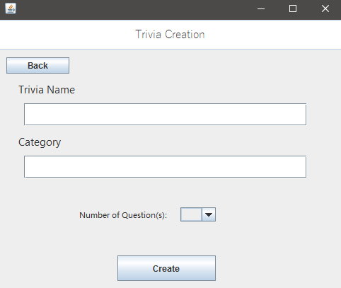

There is a process for creating your own quiz.

1. You must enter a Trivia Name, Category, and select the number of questions your quiz will have. The minimum number of questions is five. Once done, click the “Create” button.
2. A new GUI will display. You must enter **1 Question**, select the question type, choose the options that question will have and select the correct answer(s). Once done, click “Next”. This process will continue depending on how many questions you have chosen for your quiz. Once done your last question, click on “Confirm”.
3. Once you have clicked “Confirm”, it will save your information to a file and it will return to the Home Screen.

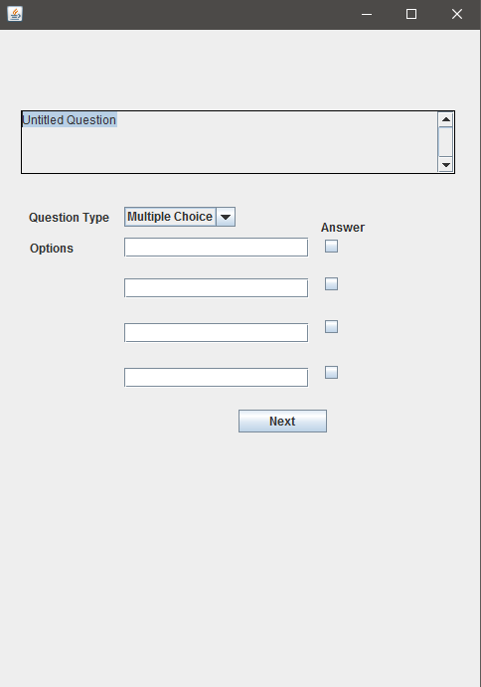

Settings:

Verify Login

Once you have clicked on “Settings” on the Home Menu, you must verify your login. Enter the username and password that you have used to login at the Login Screen. Once done, click the “Verify Login” button. If you are not granted access, it will tell you that you have enter wrong information.

Settings Screen

After verifying your login, you will see six choices (Back, Change Picture, Change Name, Change UserName, Change Password, and Seconds). 4 of these options can be used to change your information.

Change Picture

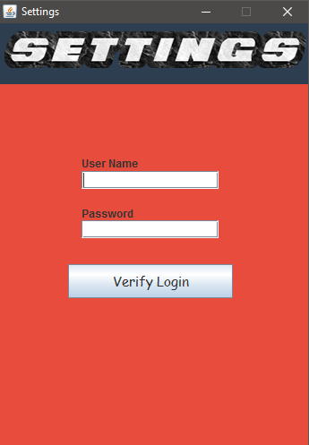

The “Change Picture” option allows you to pick a profile picture from 4 different choices.

Change Name

The “Change Name” option allows you to change your name (NOT USERNAME). Once you have entered your new name, click on “Confirm” and it will return back to the settings screen.

Change UserName

The “Change UserName” option allows you to change your username. Once you have entered your new username, click on “Confirm”. This will check if the username you have inputted is available. If it is not, it will notify the user. If it returns to the settings screen, it means the username you have inputted is available and is now yours.

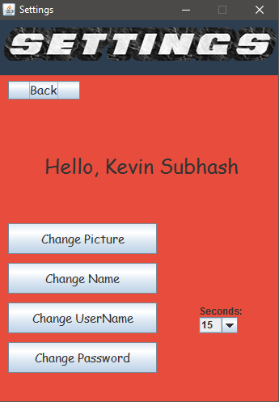

Change Password

The “Change Password” option allows you to change your password. Once you have entered the passwords, click on “Confirm”. This will check if the password and confirm password matches. If it does not, it will notify the user.

Seconds Drop Down Option

This option is for the actual game. The number of seconds you pick is the number of seconds you will receive for each question on any quiz.

Back

Once the “Back” button is clicked, it will save all the information you have changed and it will return to the Home Menu.

Actual Game:

Once you have clicked on a quiz to play (From Home Menu), it will jump into that game and can have different options. Each question should be completed before the time ends. The timer is located at the top.

Multiple Choice

You are given a number of choices. Simply click on the button that contains the answer you think is right.

True & False

You are given 2 choices, True or False. Click on the button you think is the right answer.

Check Box

You are given a various different choices. Check the options you think could be the right answer(s).

Timer

There is a timer for each question. If you don’t answer before the timer ends, you got the question wrong.

